**INTRODUCTION & SETUP**

**INTRODUCTION:**

MongoDB is a popular, open-source, document-oriented NoSQL database designed for handling large volumes of unstructured or semi-structured data. Unlike traditional relational databases that store data in rows and columns (tables), MongoDB stores data in flexible, JSON-like documents, making it ideal for applications that require fast data access and flexible data structures.

**Note: Always go through the official installation docs for better installation guide**

[**Install MongoDB - MongoDB Manual v8.0**](https://www.mongodb.com/docs/manual/installation/?msockid=0263853e7e166b3d148e915b7f8d6a40)

Note: Each Programming language has its own Mongodb-Drivers (Setup/Connect/CRUD) that is present in official document. [Start Developing with MongoDB - MongoDB Drivers](https://www.mongodb.com/docs/drivers/?msockid=0263853e7e166b3d148e915b7f8d6a40)

Node Js Driver Documentation: [mongodb](https://mongodb.github.io/node-mongodb-native/6.10/)

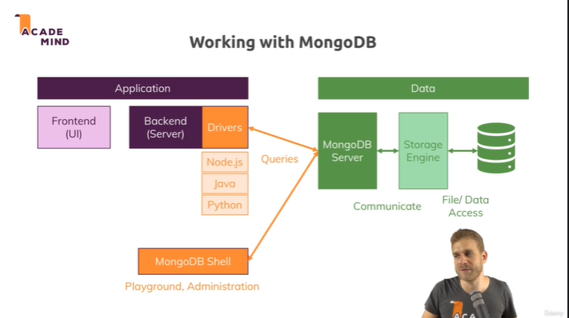

**SETUP:**

1. **Download and Install the MongoDb community Server (local Server):**

The mongodb community server allows you to run the database on your local machine. It will run as a service in your local machine. Stores the data on your local machine.

* It starts automatically as background service in your local device.
* It can be located and Start/Stop in Services > MongoDb in windows.
* It can also be Start/Stop in cmd as administrator and run ‘net start/stop mongodb’

[Download MongoDB Community Server | MongoDB](https://www.mongodb.com/try/download/community).

1. **Download the Mongodb Shell (mongosh):**

The mongodb shell allows you to interact with the database on CLI and run commands to perform CRUD operations and other administrative tasks.

[MongoDB Shell Download | MongoDB](https://www.mongodb.com/try/download/shell?msockid=0263853e7e166b3d148e915b7f8d6a40)

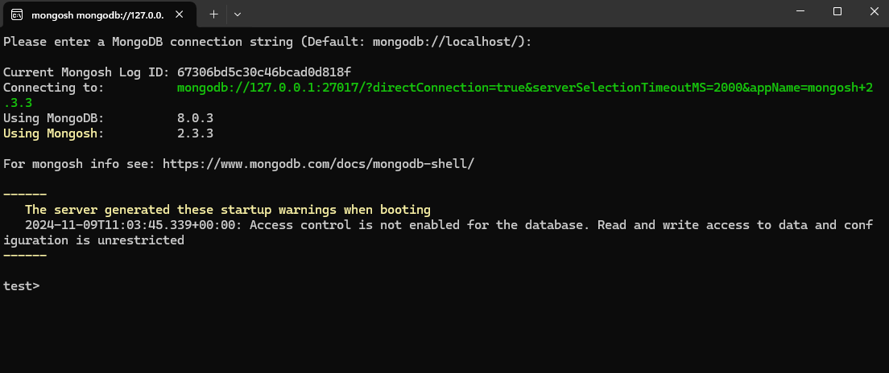

**Note:** Since Mongosh/Mongodb Shell runs on Nodejs driver we can write queries in REPL mode in js syntax

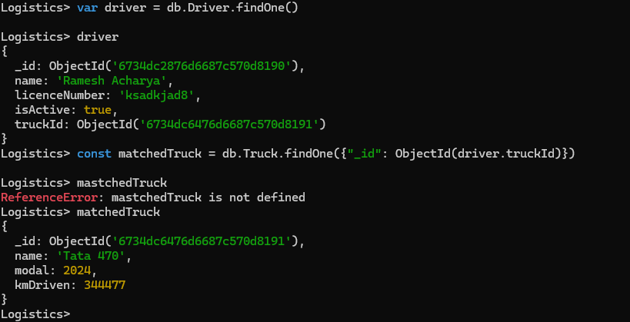

1. **Download and Install Mongodb Compass (GUI):**

The mongodb compass is used to see the Graphical User Interface of your stored data, and allows to perform CRUD operations on them.

[MongoDB Compass Download (GUI) | MongoDB](https://www.mongodb.com/try/download/compass?msockid=0263853e7e166b3d148e915b7f8d6a40)

